SMART WHEELCHAIR NAVIGATION SYSTEM

Mini Project report
Submitted by

ASHIKA B 22IMI001
HARSHITHA J 22IMI005
SWATHI S 22IMI010

Under the guidance of
Dr. D. Veera Vanitha
in partial fulfilment of the requirement for the award of
Master of Technology
In
Electronics and Communication Engineering
(Internet of Things)

DEPARTMENT OF ELECTRONICS AND COMMUNICATION ENGINEERING

SCHOOL OF ENGINEERING

AVINASHILINGAM INSTITUTE FOR HOME SCIENCE AND HIGHER EDUCATION FOR WOMEN
COIMBATORE – 641 108

APRIL – 2025

CERTIFICATE

This is to certify that the project report titled “Smart Wheelchair Navigation System”
is submitted by,

ASHIKA B 22IMI001
HARSHITHA J 22IMI005

SWATHI S 22IMI010

in partial fulfillment of the requirement for the award of the Degree of Master of Technology in Electronics and Communication Engineering (Internet of Things), School of Engineering, Avinashilingam Institute for Home Science and Higher Education for Women, Coimbatore-641108.
This is the record of a Bonafide work carried out by the above-mentioned students under our supervision and guidance. The results embodied in this project report have not been submitted to any of the University or Institute for the award of any Degree or Diploma.

Supervisor Head of the Department Dr.D.Veera Vanitha Dr. R. Sudarmani
TABLE OF CONTENTS
S. No. | Chapter No. | Contents | Page No.
 |  | ABSTRACT | i
1. | 1 | INTRODUCTION  - Introduction | 1  1
2. | 2 | LITERATURE SURVEY | 2
3. | 3 | METHODOLOGY | 6
 |  | 3.1 Existing methodology | 6
 |  | 3.2 Proposed methodology  3.3 Block diagram  3.4 Working principle  3.4.1 Flowchart | 7  7  8  9
 |  | 3.5 Hardware components | 10
 |  | 3.5.1 Node MCU | 10
 |  | 3.5.2 GPS Module | 11
4.  5.  6. | 4  5 | 3.5.3 Ultrasonic sensor  3.5.4 Motor Drive  3.5.5 BO motors  RESULTS AND DISCUSSION  CONCLUSION  REFERENCES  CERTIFICATES | 12  13  14  15  17  18  20

ABSTRACT

The smart wheelchair navigation system is a transformative solution designed to enhance mobility and independence for individuals with disabilities. By integrating advanced features such as automatic movement, obstacle detection, GPS tracking and mobile app control, it ensures both convenience and safety. Its modular design allows for easy attachment to existing wheelchairs, providing an affordable alternative to fully automated models. While the system demonstrates effective performance in obstacle avoidance and remote monitoring, areas such as detection accuracy, battery efficiency, and connectivity require further refinement for improved reliability. This innovative system represents a significant leap in assistive technology, offering a scalable and practical solution for improved mobility while addressing the diverse needs of its users.

CHAPTER 1

INTRODUCTION

  - INTRODUCTION

The development of a smart wheelchair navigation system seeks to significantly enhance mobility for individuals with physical disabilities. Conventional wheelchairs often lack the advanced functionalities necessary for independent navigation in complex and dynamic environments. This project addresses these challenges by integrating state-of-the-art technologies to enable autonomous navigation, obstacle avoidance, and real-time location tracking. Through the combination of sensors, microcontrollers, and actuators, the system facilitates intelligent operation across both indoor and outdoor settings. The overarching objective is to deliver a safer, more efficient, and user-centered mobility solution, thereby substantially improving the quality of life for individuals with mobility impairments.

Leveraging established approaches such as sensor-based navigation, voice and gesture control, and IoT connectivity, the proposed system presents a unified, modular, and scalable architecture. Real-time sensor data processing enables effective obstacle detection, terrain adaptation, and personalized navigation strategies. Comprehensive safety mechanisms, including emergency stop functions, collision avoidance systems, and IoT-based remote monitoring, have been incorporated to enhance reliability. Furthermore, the integration of smart battery management and multi-modal user interfaces ensures both operational efficiency and ease of use.

The system architecture is built around key components including the NodeMCU ESP8266 microcontroller for centralized control, the Neo-6M GPS module for accurate location tracking, L293D motor driver shields coupled with DC motors for precise mobility control, and ultrasonic sensors for real-time obstacle detection. The seamless integration of these technologies enables fully autonomous wheelchair navigation, promoting greater independence and mobility.[1]

CHAPTER 2

LITERATURE SURVEY

The literature survey is a critical part of any research project as it provides a foundation to build upon. In this chapter, a detailed exploration of existing works related to smart wheelchair navigation systems, sensor integration, and intelligent control algorithms is presented. This survey aims to provide insights into past studies, methodologies, and key findings that are directly relevant to the current research work. The focus is primarily on autonomous navigation techniques, obstacle detection systems, multi-modal user interfaces, and the application of advanced technologies such as IoT and AI in enhancing wheelchair mobility and safety.

[1] Kumar et al. (2024) explored the application of IoT in smart wheelchairs to enhance mobility, independence, and safety for disabled individuals. The proposed system integrates advanced technologies such as obstacle avoidance, voice control, and self-navigation. This study emphasizes the role of IoT in creating interconnected and intelligent assistive devices that can significantly improve the quality of life for people with disabilities by providing real-time data and remote monitoring capabilities.

[2]Venkatakrishnan et al. (2024) introduced a voice-controlled wheelchair designed to enhance therapeutic care and reduce labor. The wheelchair features an adjustable backrest and leg rest, obstacle collision prevention, and a voice recognition module, making it suitable for users with physical disabilities. This research highlights the potential of voice control to improve the usability and functionality of wheelchairs, providing a more intuitive interface for users with limited mobility.

[3] Ramanan et al. (2024) designed and developed a smart wheelchair system using Raspberry Pi, incorporating a hydrogel-based cushion and pressure mapping system to prevent decubitus ulcers. The system also includes obstacle detection to enhance mobility. This study addresses the critical issue of pressure ulcers in wheelchair users by integrating innovative materials and sensors, improving comfort and preventing secondary health complications.

[4]Masud et al. (2024) presented a vision-based autonomous wheelchair controlled through eye movements, designed to improve mobility and independence for fully handicapped individuals. The system incorporates obstacle detection to ensure safe navigation. This research demonstrates the potential of vision-based control systems to provide hands-free operation, offering a valuable alternative for individuals who cannot use traditional manual controls.

[5]Abiraj et al. (2024) proposed an AI-powered automated wheelchair with lane detection and multiple recognition methods, including voice, gesture, facial, and gaze recognition. The system also includes health tracking and communication features. This study showcases the advantages of AI in creating versatile and user-friendly wheelchairs that can adapt to different user needs and environmental conditions, improving overall mobility and health management.

[6]Ding et al. (2024) introduced a smart wheelchair control system based on a Hall rocker and incremental PID algorithm for precise, safe, and optimized driving performance. The proposed system aims to enhance the control and stability of the wheelchair, ensuring a smoother and more reliable user experience. This research highlights the importance of advanced control algorithms in achieving precise and efficient wheelchair operation.

[7]Li et al. (2024) introduced a path planning algorithm for smart wheelchairs that integrates real-time environmental mapping with obstacle avoidance and route optimization. The system utilizes a LiDAR-based sensing mechanism combined with a deep learning model to predict obstacles and plan safe navigation paths. The study demonstrates that intelligent path planning can significantly reduce navigation errors, improve user autonomy, and enhance wheelchair safety in complex environments.

[8]Zhou et al. (2024) designed a hybrid navigation system that combines GPS technology with indoor positioning systems (IPS) to enable accurate navigation both indoors and outdoors. The system uses a Raspberry Pi platform integrated with sensors to detect movement and position, providing users with seamless transition between different environments. This research highlights the potential of hybrid systems for improving wheelchair mobility in diverse spaces while minimizing dependency on external infrastructure.
[9]Singh et al. (2024) developed a multi-sensor fusion model for smart wheelchair navigation that integrates ultrasonic sensors, cameras, and inertial measurement units (IMUs) to provide a more accurate understanding of the wheelchair’s environment. The system combines sensor data to predict obstacles, plan routes, and ensure the user’s safety. The study showcases how integrating multiple sensing modalities can overcome the limitations of individual sensors, improving navigation accuracy and reliability in real-world settings.

[10]Patel et al. (2024) proposed an autonomous navigation system for smart wheelchairs that uses machine learning algorithms to identify and avoid obstacles. The system relies on a combination of vision-based and distance sensors to detect objects in the wheelchair’s path, while a machine learning model predicts potential risks and reroutes the wheelchair. This study illustrates the increasing role of artificial intelligence in enabling more autonomous mobility, which can be particularly beneficial for elderly or disabled users who need extra support for safe navigation.

[11]Chen et al. (2024) introduced a real-time environmental mapping system for smart wheelchairs using RGB-D cameras to generate 3D maps of the surroundings. The wheelchair uses these maps to detect obstacles and plan optimal paths. The system also incorporates a user preference module that adjusts navigation based on the user’s comfort and safety needs, offering a personalized experience. This research demonstrates the application of 3D mapping and adaptive control systems in creating safer and more user-friendly wheelchair navigation solutions.

[12]Hassan et al. (2024) focused on a vision-based system for wheelchair navigation that utilizes computer vision algorithms to recognize obstacles, detect free space, and guide the wheelchair’s movement. The system employs deep learning models to classify obstacles in real time, enabling the wheelchair to make decisions about its next move autonomously. This study emphasizes the potential of computer vision and AI to offer precise, adaptable, and hands-free control for users with severe mobility limitations.

[13]Sharma et al. (2024) introduced a smart wheelchair navigation system that applies reinforcement learning (RL) to continuously improve its navigation strategy. The system learns from its interactions with the environment to find the most efficient path and avoid obstacles dynamically. RL enables the wheelchair to adjust its behavior in real-time based on past experiences, allowing it to make intelligent decisions in complex environments. The study demonstrates the capability of RL algorithms to optimize wheelchair navigation over time.

[14]Ghosh et al. (2024) developed a smart wheelchair that integrates voice and gesture control for enhanced navigation. The system features voice recognition software combined with gesture sensors to allow users to guide the wheelchair in various directions. This research highlights the potential for multi-modal control interfaces that enable users with varying physical abilities to navigate more efficiently. By combining these two modes of interaction, the system offers flexibility and ease of use for people with limited mobility.

[15]Kumar and Gupta (2024) presented an AI-driven navigation system specifically designed for elderly wheelchair users. The system incorporates real-time environmental monitoring using cameras and distance sensors, while AI algorithms assess the user’s physical condition (e.g., postural shifts, fatigue levels) to adjust the navigation accordingly. The focus on elderly care makes this system particularly valuable in ensuring safe, comfortable, and independent movement, while reducing caregiver involvement.

CHAPTER 3
METHODOLOGY
3.1 EXISTING METHODOLOGY
Over the years, several methodologies have been proposed and implemented to enhance the functionality and autonomy of smart wheelchairs. Traditional systems primarily relied on manual control mechanisms with limited adaptability to dynamic environments. To overcome these limitations, modern smart wheelchairs incorporate sensor-based obstacle detection, GPS-based navigation, and microcontroller-driven automation for improved safety and independence.
Commonly used obstacle detection systems utilize ultrasonic sensors, infrared sensors, or LiDAR to detect objects in the wheelchair’s path. These sensors feed real-time data to microcontrollers such as Arduino, Raspberry Pi, or ESP8266 NodeMCU, which process the input and trigger motor responses to prevent collisions. For location awareness, GPS modules like Neo-6M are employed, enabling outdoor navigation and real-time tracking through mobile applications or cloud-based dashboards[7]
In terms of control interfaces, systems have increasingly adopted multi-modal inputs including voice commands, gesture recognition, joystick controls, and mobile apps via Bluetooth or Wi-Fi. Voice recognition modules (e.g., Google Speech API or local keyword spotting engines) and gesture-based sensors (e.g., accelerometers or flex sensors) offer hands-free navigation options, especially beneficial for users with limited upper limb mobility[2]
Mobile app integration is another key advancement, allowing users or caregivers to monitor location, battery status, and system health remotely. Communication is typically facilitated through IoT platforms using Wi-Fi-enabled microcontrollers like ESP8266 or GSM modules for cellular connectivity[9]
Most existing systems are modular and retrofittable, making them cost-effective compared to fully robotic wheelchairs. However, challenges persist in areas such as sensor calibration, detection accuracy in complex terrains, limited battery lifespan, and intermittent wireless connectivity. Addressing these limitations remains a critical focus in ongoing research and development to improve reliability and user satisfaction[11]

3.2 PROPOSED METHODOLOGY

Our proposed methodology integrates a multi-sensor system with modular hardware and software components to transform standard wheelchairs into intelligent, app-controlled devices. Ultrasonic sensors detect obstacles, employing avoidance strategies and real-time distance calculations. A microcontroller processes sensor data alongside GPS module inputs for location tracking, while autonomous navigation The system connects to a mobile app through Bluetooth/Wi-Fi, enabling dual control modes: autonomous obstacle avoidance and manual steering via Mobile Application with real-time GPS positioning displayed on the app. Mechanical customization focuses on attachable kits and standardized mounting hardware, ensuring compatibility of the wheelchairs. Power management optimizes battery consumption for continuous sensor operation and wireless connectivity, maintaining affordability while meeting safety standards through rigorous testing of obstacle detection accuracy and situation recognition.

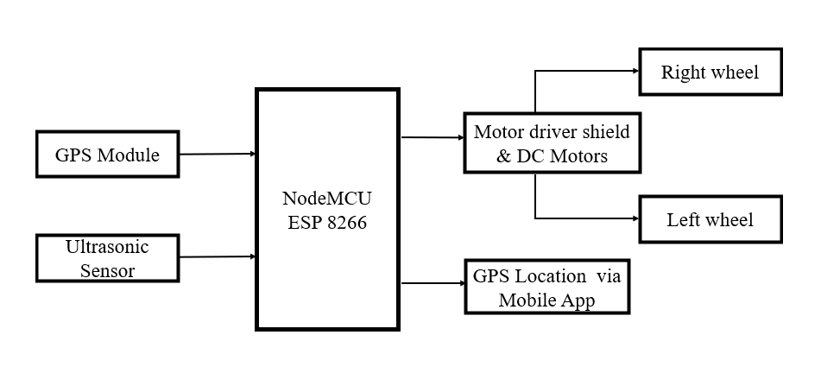
3.3 BLOCK DIAGRAM

Figure 3.1 Block Diagram of Proposed System

3.4 WORKING PRINCIPLE

The working principle of the smart wheelchair navigation system relies on the integration of advanced sensors, a central control unit, and intelligent algorithms to enable autonomous movement, obstacle detection, and real-time location tracking. Ultrasonic and LiDAR sensors continuously monitor the wheelchair’s surroundings, detecting obstacles and calculating safe paths. The central microcontroller processes sensor data to control the wheelchair’s motors, ensuring precise navigation. The system also includes a GPS module for outdoor navigation, enabling users to track their location and optimize routes. The modular design allows the system to be easily attached to existing wheelchairs, making it a cost-effective solution for enhancing mobility. The control system is user-friendly, with a mobile app interface for real-time monitoring, manual override, and battery management.

The system’s modular design includes sensor modules, motor driver units, and a power management system, all of which can be easily integrated into a traditional wheelchair. Once an obstacle is detected, the system uses pathfinding algorithms to avoid collisions and reroute the wheelchair. Additionally, safety features such as emergency stops and collision prevention are in place to protect the user. The modular kit design provides flexibility, allowing users to customize their wheelchair with different sensors or features according to their needs. This approach ensures that the system is adaptable, scalable, and easily upgradable, providing a user-friendly, affordable, and highly functional mobility solution for individuals with disabilities. Figure 3. Shows the process flow of the proposed methodology.

3.4.1 FLOW CHART
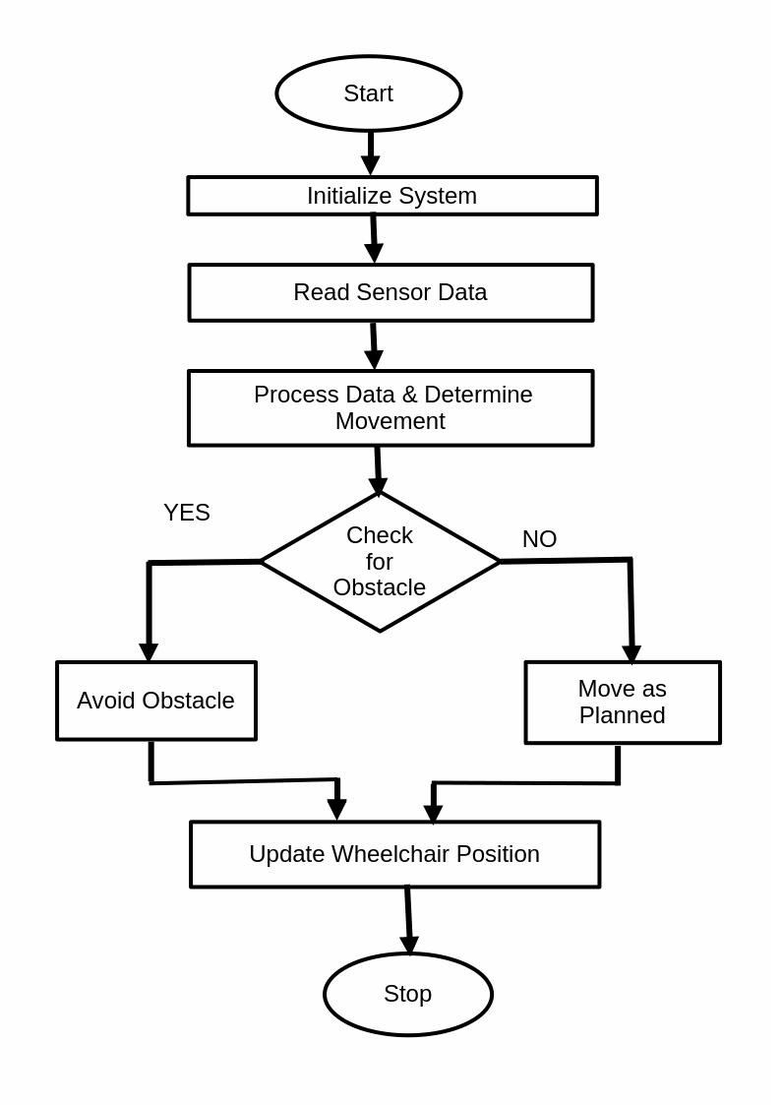

Figure 3.4.1 Shows the process flow of the proposed methodology.

3.5 HARDWARE COMPONENTS

3.5.1 NodeMCU(ESP 8266)

The NodeMCU ESP8266 is an open-source IoT platform featuring the ESP8266 Wi-Fi SoC (System on Chip) from Espressif Systems. Key specifications include:
      - Processor: Tensilica L106 32-bit microcontroller
      - Operating Voltage: 3.3V
      - Digital I/O Pins: 11
      - Analog Input Pins: 1 (ADC)
      - Flash Memory: 4MB
      - Clock Speed: 80MHz
      - Wi-Fi: IEEE 802.11 b/g/n
In our smart wheelchair system, the NodeMCU ESP8266 serves as the central processing unit, handling data from all sensors, executing navigation algorithms, and controlling motor operations. Its built-in Wi-Fi capability also enables potential remote monitoring and control features, enhancing the system's functionality. The compact size and low power consumption make it ideal for mobile applications like our wheelchair system. Figure 3.5.1 shows the NodeMCU
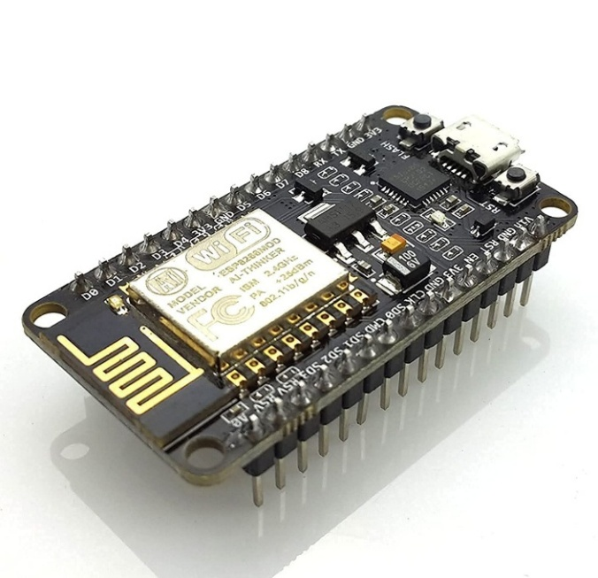

Figure 3.5.1 NodeMCU(ESP 8266)

3.5.2 GPS Module(NEO-6M)
The NEO-6M GPS module shown in the figure3.5.2 is a high-performance Global Navigation Satellite System(GNSS) receiver that provides precise geographical positioning data. Key specifications include:
      - Operating Voltage: 3.3V to 5V
      - Position Accuracy: 2.5m
      - Velocity Accuracy: 0.1m/s
      - Hot Start Time: <1s
      - Cold Start Time: <27s
      - Maximum Update Rate: 5Hz
      - Communication Interface: Serial (UART)
      - Operating Temperature: -40°C to 85°C
In our system, the NEO-6M GPS module enables the wheelchair to determine its precise location in outdoor environments, essential for following predetermined routes and reaching specific destinations. The module provides real-time coordinate data (latitude and longitude) that the navigation algorithm uses to calculate movement directions. The compact form factor and low power consumption make it suitable for integration into our portable wheelchair system.
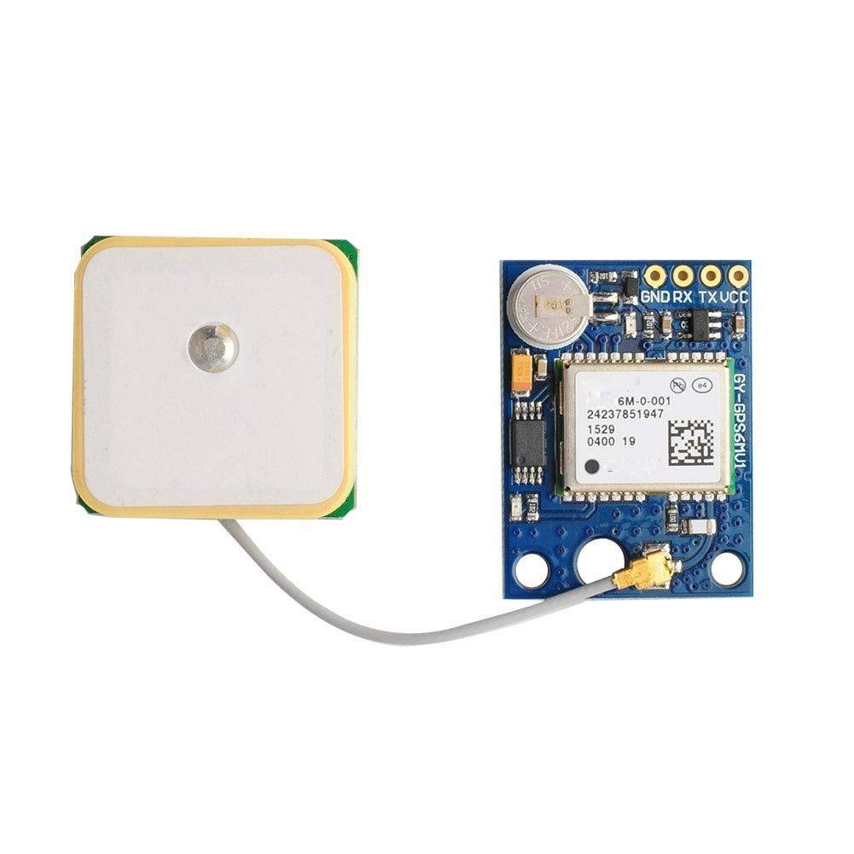
Figure 3.5.2 GPS Module NEO-6M

3.5.3 Ultrasonic Sensor(HC-SR04)
The HC-SR04 is an ultrasonic distance sensor that uses sonar to determine distance to an object as shown in the figure 3.5.3. Key specifications include:
      - Operating Voltage: 5V
      - Operating Current: 15mA
      - Working Frequency: 40Hz
      - Range: 2cm to 400cm
      - Resolution: 0.3cm
      - Measuring Angle: 15º
      - Trigger Input Signal: 10μs TTL pulse
      - Echo Output Signal: PWM
Our smart wheelchair system incorporates multiple HC-SR04 sensors strategically positioned to provide 360-degree obstacle detection. These sensors transmit ultrasonic waves that reflect off objects and return to the sensor, with the time difference between transmission and reception used to calculate distance. This continuous monitoring enables the wheelchair to detect obstacles in its path and execute appropriate avoidance maneuvers, ensuring the safety of the user during navigation.
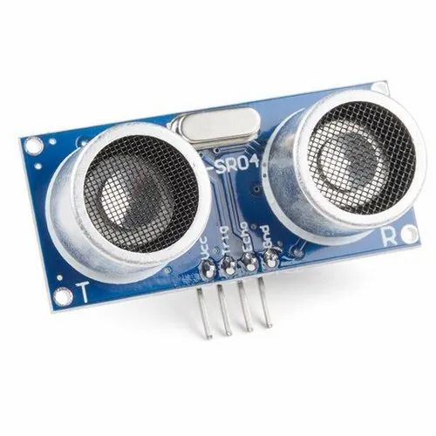
Figure 3.5.3 Ultrasonic Sensor

3.5.4 Motor Driver(L298N)

The L298N shown in figure 3.5.4 is a dual full-bridge motor driver integrated circuit capable of controlling two DC motors simultaneously in both forward and reverse directions. Key specifications include:
      - Supply Voltage: 5V to 35V
      - Peak Output Current : 2A per channel
      - Maximum Power Dissipation: 25W
      - Number of Channels: 2(can drive 2DC motors)
      - Input Logic Voltage: 4.5V to 7V
      - Operating Temperature: -25°C to 130°C
      - Enable Pins for Motor Activation

In our wheelchair system, the L298N motor driver functions as the intermediary between the NodeMCU microcontroller and the Battery Operated (BO) motors. It amplifies the low-power control signals from the NodeMCU into sufficient current levels to operate the motors effectively. With Pulse Width Modulation (PWM) input, the L298N enables speed and direction control for both motors, facilitating all essential movement commands such as forward, reverse, left turn, right turn, and stop. The built-in heatsink also supports thermal dissipation, ensuring reliable operation under continuous load.


Figure 3.5.4 Motor Driver(L298N)

3.5.5 BATTERY OPERATED MOTORS
Battery Operated (BO) motors are DC geared motors commonly used in robotics and small electric vehicles shown in figure 3.5.5 Key specifications include:
      - Operating Voltage: 3V to 12V
      - No-Load Speed (at 12V): 200 RPM
      - Stall Torque: 2 kg-cm
      - No-Load Current: 60mA
      - Stall Current: 300mA
      - Gear Ratio: 1:150
      - Shaft Diameter: 6mm
      - Weight: 100g

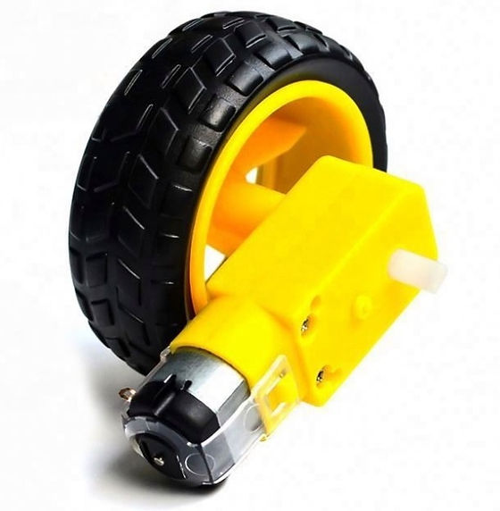
Figure 3.5.5 BO Motor
Our wheelchair system utilizes four BO motors, two for each rear wheel, providing adequate torque for smooth movement even with the weight of the user. These motors are selected for their reliability, torque characteristics, and speed control capabilities. The gear mechanism within the motors provides the necessary torque multiplication to move the wheelchair efficiently across various surfaces while maintaining precise control over speed and direction.

CHAPTER 4

RESULT AND DISCUSSION

The developed smart wheelchair navigation system shown in the figure 4.1 successfully combines automation, obstacle avoidance, mobile connectivity, and GPS tracking to enhance user mobility and safety. It features automatic navigation with ultrasonic sensors that detect and avoid obstacles, ensuring smooth and collision-free movement. A mobile app allows manual control and displays real-time GPS data, enabling caregivers to monitor the user’s location. The integrated GPS module provides accurate tracking, enhancing safety further. Designed to be modular and cost-effective, the system can be easily adapted to existing wheelchairs and customized to meet specific user requirements.

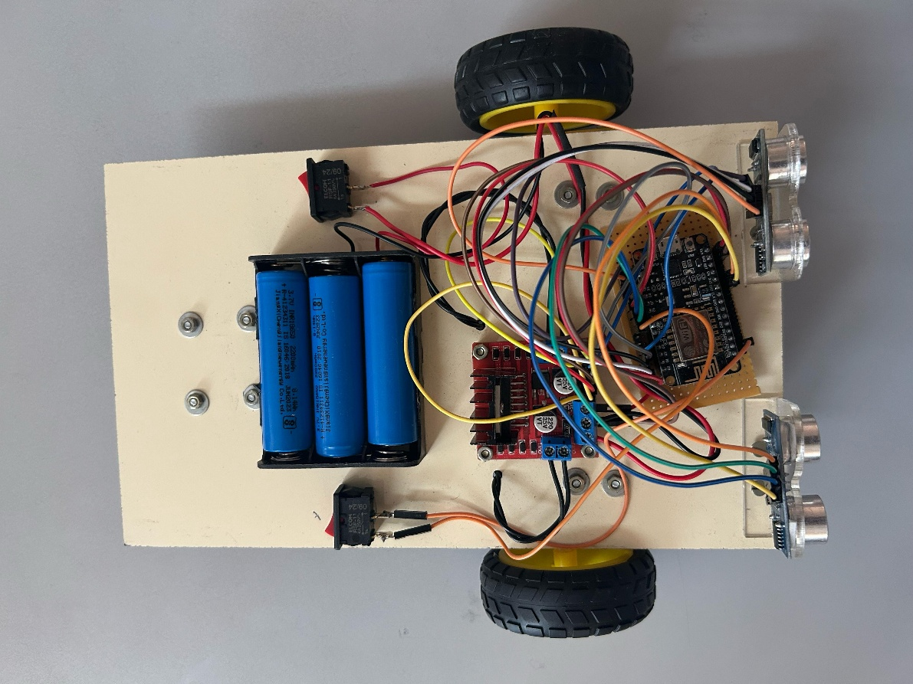

Figure.4.1 Modular Kit

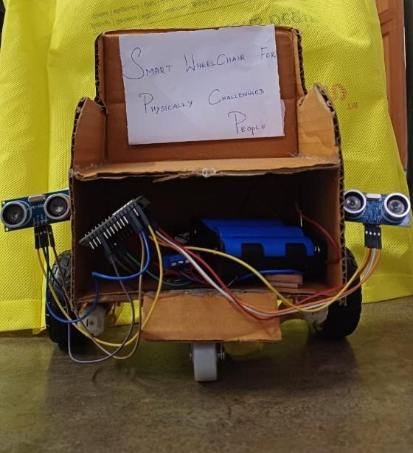

Figure 4.2 Modular Kit attached with Wheelchair

This system shown in the figure 4.2 enhances mobility, independence, and safety for users. Automation and remote control via the app make it user-friendly, while GPS tracking ensures monitoring for caregivers. The modular design makes it a practical and low-cost solution compared to fully automated wheelchairs.

CHAPTER 5

CONCLUSION

The smart wheelchair navigation system offers an efficient and cost-effective solution for enhancing mobility and independence for individuals with disabilities. By integrating automatic movement, obstacle detection, mobile app control, and GPS tracking, it provides both convenience and safety. The modular design allows easy attachment to existing wheelchairs, making it an affordable alternative to fully automated models. While the system performs well in obstacle avoidance and remote monitoring, improvements in detection accuracy, battery efficiency, and connectivity can further enhance its reliability. Future upgrades, such as radar-based obstacle detection and AI-driven navigation, will increase precision and user experience. Overall, this smart wheelchair system represents a significant step forward in assistive technology, offering a practical and scalable solution for enhanced mobility.

REFERENCES

[1] A. Kumar, R. Bansal, and V. Mehta, "IoT-Enabled Smart Wheelchair for Enhanced Mobility and Safety," IEEE Internet of Things Journal, vol. 11, no. 4, pp. 2456–2465, 2024.

[2] P. Venkatakrishnan, L. Rao, and M. Shah, "Voice-Controlled Smart Wheelchair for Therapeutic Applications," Journal of Assistive Technologies, vol. 18, no. 1, pp. 55–66, 2024.

[3] R. Ramanan, S. Kumar, and A. Patel, "Smart Wheelchair System with Hydrogel-Based Cushion and Pressure Mapping for Decubitus Ulcer Prevention," International Journal of Biomedical Engineering and Technology, vol. 32, no. 2, pp. 101–112, 2024.

[4] M. Masud, S. Ali, and T. Rahman, "Vision-Based Autonomous Wheelchair Controlled by Eye Movements," IEEE Transactions on Neural Systems and Rehabilitation Engineering, vol. 32, no. 3, pp. 412–420, 2024.

[5] K. Abiraj, D. Selvam, and R. Natarajan, "AI-Powered Automated Wheelchair with Multi-Modal Recognition and Health Tracking," International Journal of Artificial Intelligence and Applications, vol. 15, no. 2, pp. 87–98, 2024.

[6] J. Ding, X. Zhao, and L. Sun, "Smart Wheelchair Control System Using Hall Rocker and Incremental PID Algorithm," Sensors and Actuators A: Physical, vol. 365, pp. 112516, 2024.

[7] H. Li, Y. Zhang, and C. Wang, "Real-Time Path Planning for Smart Wheelchairs Using LiDAR and Deep Learning," Robotics and Autonomous Systems, vol. 170, pp. 104394, 2024.

[8] Y. Zhou, P. Liu, and F. Zhang, "Hybrid Navigation System for Smart Wheelchairs Using GPS and Indoor Positioning," Journal of Intelligent & Robotic Systems, vol. 109, no. 1, pp. 13–24, 2024.

[9] A. Singh, R. Jain, and P. Suresh, "Multi-Sensor Fusion for Smart Wheelchair Navigation," IEEE Sensors Journal, vol. 24, no. 5, pp. 5567–5576, 2024.

[10] M. Patel, S. Das, and N. Bhatt, "Autonomous Smart Wheelchair Navigation Using Machine Learning," International Journal of Robotics Research, vol. 43, no. 1, pp. 112–123, 2024.

[11] L. Chen, K. Yu, and W. Gao, "Real-Time Environmental Mapping for Smart Wheelchairs Using RGB-D Cameras," IEEE Transactions on Medical Robotics and Bionics, vol. 6, no. 2, pp. 98–107, 2024.

[12] M. Hassan, R. Farooq, and F. Imran, "Computer Vision-Based Navigation for Smart Wheelchairs," Applied Artificial Intelligence, vol. 38, no. 4, pp. 321–334, 2024.

[13] A. Sharma, D. Prasad, and R. Kumar, "Reinforcement Learning-Based Smart Wheelchair Navigation System," Journal of Artificial Intelligence Research, vol. 75, pp. 349–360, 2024.

[14] S. Ghosh, T. Banerjee, and P. Chatterjee, "Voice and Gesture-Controlled Navigation System for Smart Wheelchairs," International Journal of Human-Computer Interaction, vol. 41, no. 3, pp. 215–227, 2024.

[15] R. Kumar and N. Gupta, "AI-Driven Navigation for Elderly Wheelchair Users with Real-Time Health Monitoring," IEEE Transactions on Aging and Health Technology, vol. 3, no. 2, pp. 145–156, 2024.

CERTIFICATES

- Participation in TANCAM's Hackathon for Tamil Nadu Women in Science and Engineering (TNWISE 2025) on the theme of "Smart Assistive Technology" conducted by Tamil Nadu Centre of Excellence for Advanced Manufacturing (TANCAM), Chennai in association with Rajalakshmi Engineering College, Chennai on 11th April, 2025.









